**AEM Project Setup using Maven**

**Prer**equisite: Local must have Maven and Java installed to create and deploy created project.

Two **types of maven archetypes** are used to create maven project. Set **aemVersion=cloud** for AEM as a cloud service  
Set **aemVersion=6.5.0** for AEM as Adobe Managed Services or on-premises

Following below steps to create project:

Hit below command in command prompt and traverse to specific folder where we want to create Adobe Experience Manager project. It will take few minutes to create project:

mvn -B archetype:generate -D archetypeGroupId=com.adobe.aem -D archetypeArtifactId=aem-project-archetype -D archetypeVersion=25 -DaemVersion=6.5.0 -D appTitle="My App Example" -D appId="my-app" -D groupId="com.adobe.aem.myapp" -D artifactId="myapp" -D frontendModule="none" -D includeExamples="y" -D includeDispatcherConfig="n"

The build was failure because of Groovy error



Which can be fixed by modifying groovy version from 2.4.16 to 2.4.8 in pom file exist in below path.

C:\Users\sswain\.m2\repository\org\apache\maven\archetype\archetype-common\3.2.1\ archetype-common-3.2.1.pom

Existing version Modified version

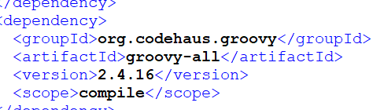 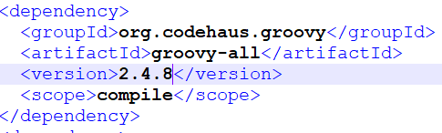

Although the build was failure but the project created in the desired folder.In my case it is the path: C:\AEM\workspace

To restart the process, delete this project and re-hit the command in command prompt.



**Build and deploy the project code to a local instance of AEM**

1.Ensure you have an author instance of AEM running locally on port **4502**.

2.From the command line, navigate into the myapp project directory.



3.Run the following command to build and deploy the entire project to AEM:

**mvn clean install -PautoInstallPackage -Daem.host=localhost -Daem.port=4502 -Dvault.user=admin -Dvault.password=\***

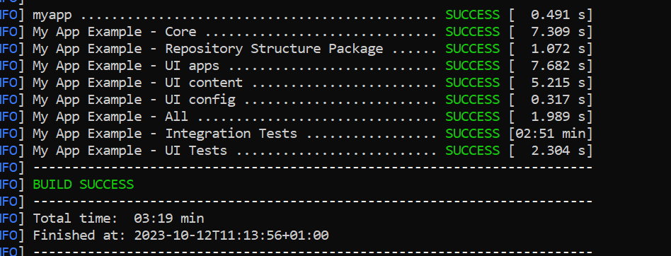

Now the Project successfully created in the AEM as well.

